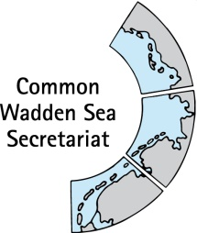

TASK GROUP
World Heritage
TG-WH 32

29 January 2021
Virtual Meeting

_________________________________________________________________________

Agenda Item: 3

Subject: Announcements CWSS

Document No. TG-WH 32/3/1

Date: 27 January 2021

Submitted by: CWSS

_________________________________________________________________________

Attached are announcements from CWSS.

Proposal

The meeting is proposed to note the announcements.

Announcements CWSS
(27 January 2020)

First results of 2020 flyway count published

In January 2020, the third Total Count of the East Atlantic Flyway was organized. All waterbirds wintering along the coast from Norway till South Africa were counted in an enormous operation: this year 12,000 volunteers and professionals contributed to it. This collaboration and simultaneous count are of upmost importance to gain insight into the trends of the various bird populations using the Flyway. The now published compilation of national reports gives a first overview of the bird numbers counted in 32 countries along the Flyway. The census was organized by Sovon Vogelonderzoek in collaboration with the Wadden Sea Flyway Initiative, Wetlands International and BirdLife International together with national authorities, organisations and institutions that are responsible for waterbird and wetland monitoring in their country.

Avian flu in the Wadden Sea World Heritage

Since the end of October, the Wadden Sea coast from Denmark to the Netherlands has seen a massive outbreak of bird flu. The NGO WWF even speaks of "unprecedented dimensions". The impact is monitored in all three Wadden Sea countries
https://www.waddensea-worldheritage.org/news/avian-flu-wadden-sea-world-heritage

New report on breeding birds in the Wadden Sea published
About 395,000 breeding pairs of coastal breeding birds occur in the transnational Wadden Sea, of which 75% inhabit the islands and Halligen. Overall, 18 from 33 species (55%) have experienced decreases since the start of the monitoring scheme in 1991. Most decreases are reported from the western part of the Wadden Sea in the Netherlands and Lower Saxony, but the data also point at intriguing regional dynamics in breeding numbers. These are the main results of the recently published progress report ‘Breeding Birds in the Wadden Sea - Trends 1991-2017 and results of total counts in 2006 and 2012’. The report provides baseline information on trends in breeding numbers in the period 1991-2017 and an account on total counts in 2006 and 2012, all carried out in the framework of the Trilateral Assessment and Monitoring Programme (TMAP) of the Trilateral Wadden Sea Cooperation.
https://www.waddensea-worldheritage.org/sites/default/files/2020_Ecosystem40_breeding%20birds.pdf

New colleagues at the Common Wadden Sea Secretariat: Kristine Meise and Marine Perrin

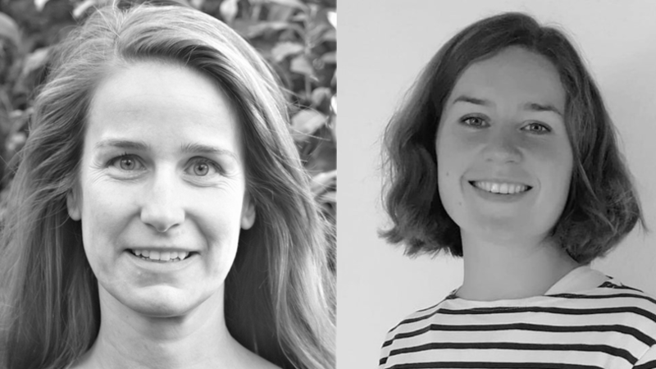
With the start of 2021, Gerold Lüerßen, who helped built up the Trilateral Wadden Sea Cooperation in his almost 25 years of service, began his well-deserved retirement. On 15 January, his tasks were picked up by CWSS’s new staff member Dr. Kristine Meise (left). Kristine joins CWSS with an academic career with a focus on understanding how the physical and social environment shapes animal communities. She also brings over 10 years of international research and management experience that provide her with a good understanding of the conservation challenges arising from opposing ecological needs and socioeconomic interests and the need to address both aspects at the same time to develop sustainable solutions.
Another new face at CWSS is Marine Perrin (right), who interned at CWSS in fall 2020 and has now returned as short-term project assistant until April 2021 to support the development of the single integrated management plan with the development of legal framework databases for Shipping, Fisheries, Energy, Coastal Protection and Tourism.

Webinar towards a trilateral sediment solutions Community of Understanding

On 27 November, the trilateral webinar Sediment Solutions was held. The agenda of the webinar focussed on the content of sediment solutions issues and on the inventory of the interest for a trilateral sediment solutions Community of Understanding, with contributions of several people from Denmark, Germany and the Netherlands. The event was organized by the Programme Towards A Rich Wadden Sea, Deltares, the Common Wadden Sea Secretariat, Rijkswaterstaat and NLWKN. The process of establishing a Community of Understanding is financially supported by Interreg-EDR.
Presentations, fact sheets and additional information

New Wadden Sea World Heritage face masks distributed among partners

Together with partners from the Netherlands, Germany and Denmark as well as graphic designer Wild at Art, the Common Wadden Sea Secretariat has produced the first Wadden Sea World Heritage face masks. The masks show one of the iconic flying five: the oystercatcher.
As the pandemic is not yet overcome, the masks serve as eye catcher and conservation starter on the Wadden Sea World Heritage. The first batch of masks was therefore funded by the Trilateral Wadden Sea Cooperation and distributed among the Cooperation’s countless partners from national parks to visitor centres and multipliers with a sincere thank you for their contribution. 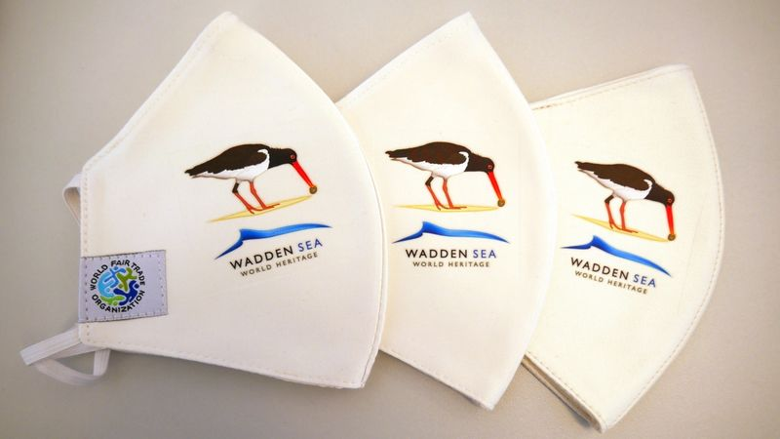
Available in English, Danish, Dutch and German, the masks are made from fair trade cotton and are washable to prevent waste, especially litter in nature. The first batch is considered as trial run. If there is interest to order more – for sale or distribution, partners are invited to get in touch directly with the supplier Wild at Art.

